**Installation Guide for the PDF2Excel Converter (TM PO) Tool**

**Step 1 : Install the Web Server Application – XAMPP**

* **Navigate to** [***https://www.apachefriends.org/index.html***](https://www.apachefriends.org/index.html)
* **Then download the installer for XAMPP**

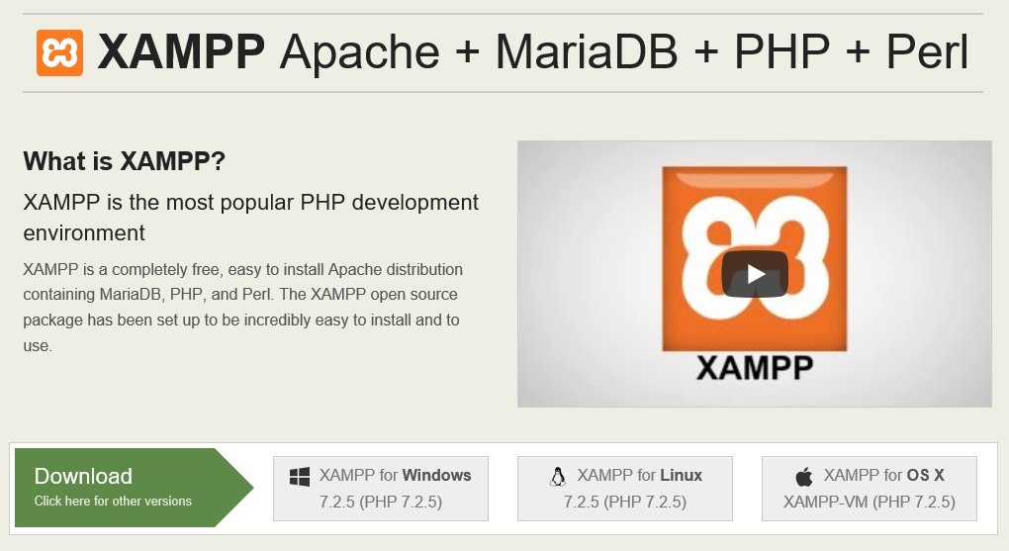

**🡪 When the installation is done, XAMPP’s project directory can be found**

**in (C:\xampp\htdocs).**

**Step 2 : Copy the related files into the Project Directory**

* **This is what the PDF2Excel.rar files contains.**

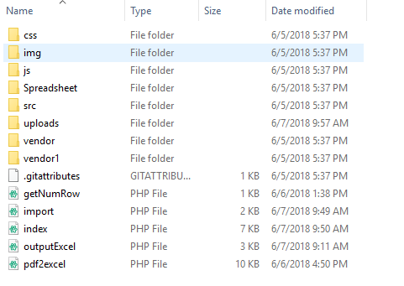

* **Extract the .rar file into this directory (C:\xampp\htdocs\) for the server to read the files.**
* **The below image displays the content of *htdocs* after the extraction is done. Make sure that the PDF2Excel folder is present.**

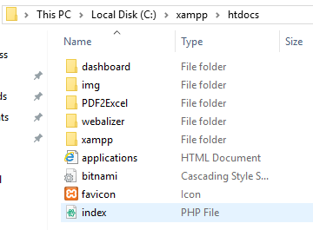

**Step 3 : Activate the Web Server Application –XAMPP Control Panel**

* **Search for the installed XAMPP Control Panel and open it. It will look like this:**

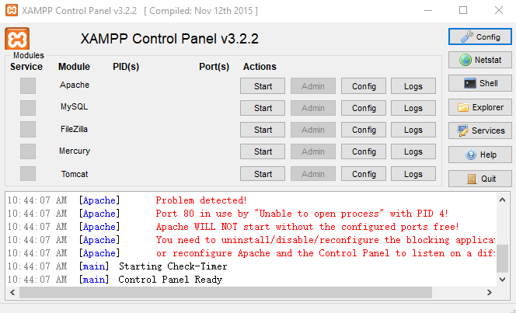

* **Then click on the ‘Start’ button for the Apache Module. The Start button should change to ‘Stop’ if it is activated.**

**Tips: If you encounter the problem stating that *‘Port 80 is in use by Unable to open process with PID 4..’*, please follow the link below to solve it:** [***https://www.youtube.com/watch?v=K_rZ-7hTI5Q***](https://www.youtube.com/watch?v=K_rZ-7hTI5Q)

**Step 4 : Start using the PDF2Excel Converter Tool**

* **Now your computer has been set up as a local web server. To use the PDF2Excel Converter tool, open any browser (e.g.: Internet Explorer) and then type in *‘http://localhost:8080/PDF2Excel/index.php’* in the URL tab. Take note that, ‘8080’ is the port number being used, the port number that you are using might differs from the image below.**



* **Now, the tool is ready to be used.**

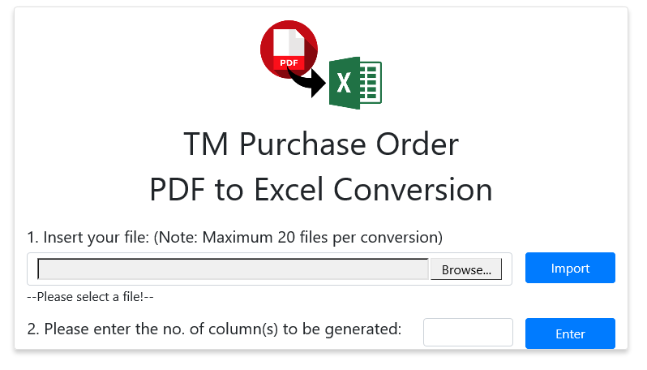

**Features:**

* **Able to process pdf in batch (max: 20 pdf)**
* **Allow column(s) options that provides flexibility for the excel file generation.**